Deliverable 2 - Written Analysis:

1. **Overview of the analysis:**

The purpose of the assignment was to create a filterable webpage for presenting the data.

1. **Results:**

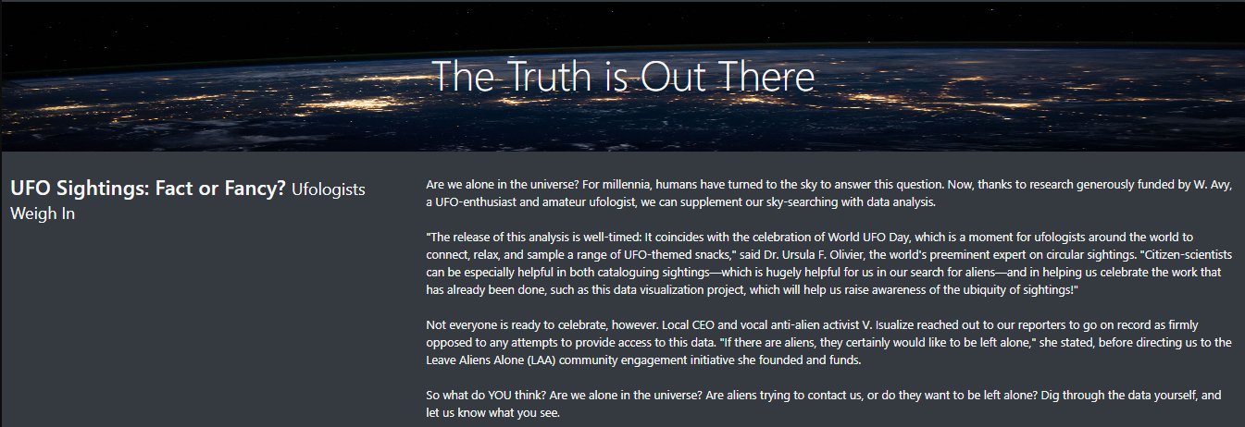

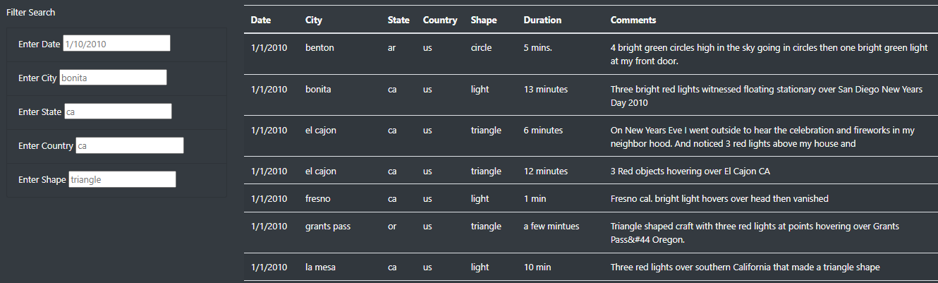

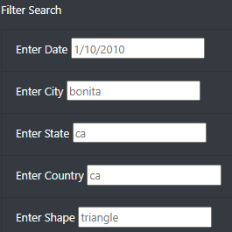

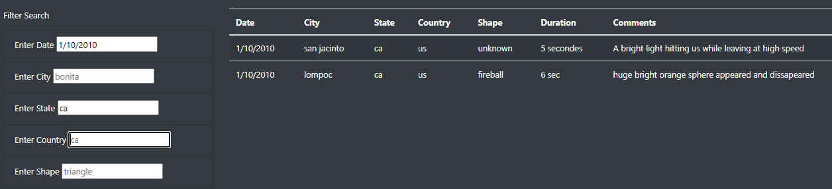

1. **Summary:** Drawbacks and Recommendations

* The locations of UFO sightings should be presented on a map for a better visualization of the data.
* The dropdowns help to search the data effectively.